

Automated face mask Detection Techniques using Computer vision

User Manual



May 30, 2021

**Prerequisites**

**Step1:- Python Installation**

* Open command prompt and type “python --version”

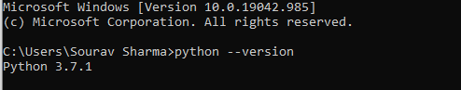

* If python is installed on your system then it will show python version.
* Otherwise you have to install it.
* Click on the link <https://www.python.org/downloads/>

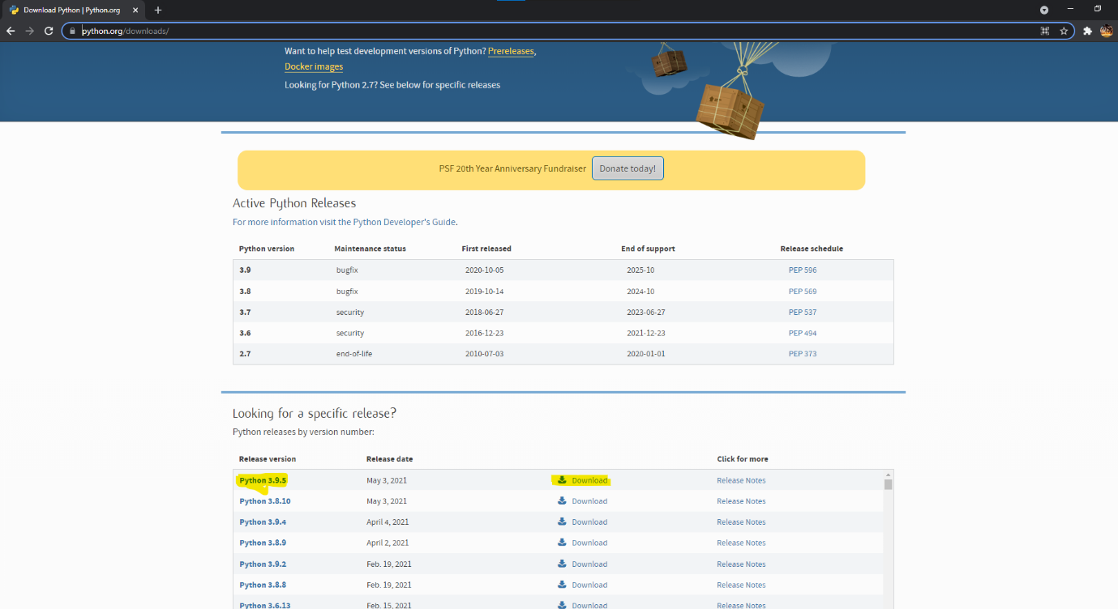

* Select the latest version of python which is compatible to your machine and download it.

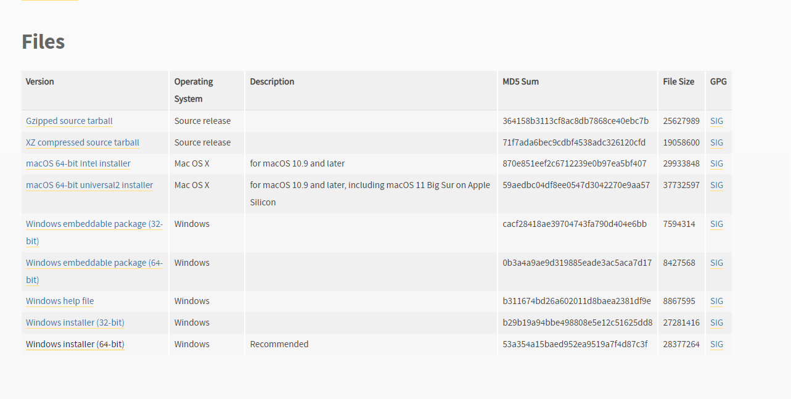

* After download is complete, open the exe file and select the that are checked in the below image.

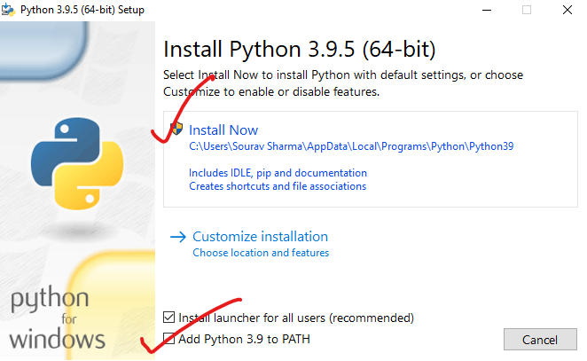

* After Installation, open command prompt and type “python --version”.



* This time it will surely show you python version you have installed.

**Step 2:- Installing required libraries**

* Open command prompt and type “pip install pillow”. If you have already installed it then it will show “Requirement Satisfied.”



* Type “pip install opencv-python”. If you have already installed it then it will show “Requirement Satisfied.”



* Type “pip install opencv-contrib-python”. If you have already installed it then it will show “Requirement Satisfied.”



**Step 3:- MySQL Installation**

* Click on link for downloading MySQL.

Link:- <https://dev.mysql.com/downloads/installer/>

* Download the windows Installer.

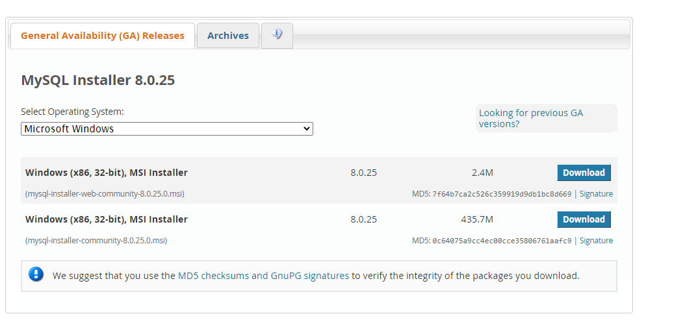

* After download is complete, Open the exe file and start installation.

**Note:- Remember the database username and password you have set at the time of installation.**

**Note:- Don’t create any database. It should be completely empty.**

**Note:- Make sure you install all these software before using the face/mask recognizer.**

**Steps for configuring the Recognizer:-**

* Download it from the website from where you download the User Mannual.
* After download is complete, extract the contents of “Final setup” to any location you want.
* After extraction, double click on the “good face” exe file. It will take some time to open.
* After that Login page will open. As you are new user so you have to sign in and configure the recognizer. Click on “sign up”.

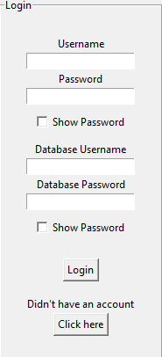

* Enter your full name and set you username & password. Then click on “sign up”.

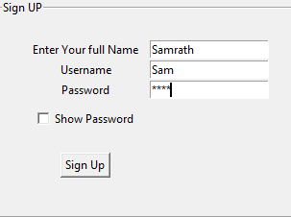

* After that “Sign up Done Successfully” will be displayed. Click on next.

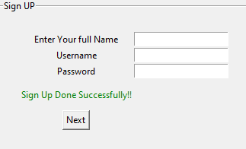

* Now you have to configure the recognizer by creating the table you want data to be stored to and adding the desired path.

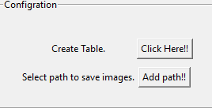

**Note:- First create table then add path.**

* Click on “Click here”.
* Enter you database username and password that you have set at the time of installation.

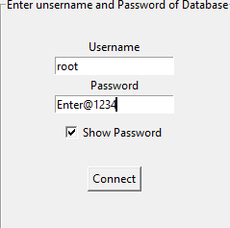

* Enter database name and click on “create”.

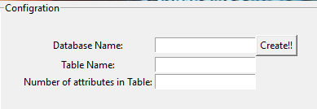

* Enter table name and click on “create”.
* Select number of attributes.

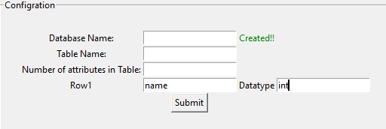

* Then after that add attribute name and its data type.
* After that click on submit.
* Kudos you have successfully configured database and table.

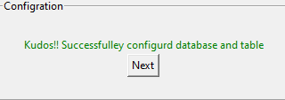

* Now click on “Add path!!”.

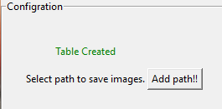

* Here you have to select the folder where images would be stored.

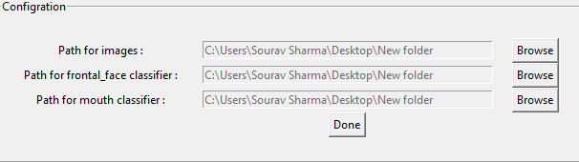

* And the folder where you have extracted the “Final Setup”.
* Click on “Done”.
* Configuration is complete. Now you are ready to use recognizer.

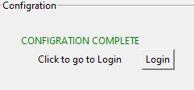

* Go to login.

**Steps for using the recognizer.**

* Enter the credentials and click on login.

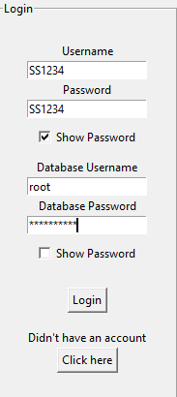

* Click on “Add user to database”.

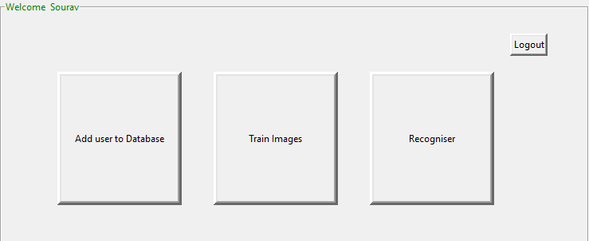

* Enter the details new person you want to add to database. Then click on “submit”.

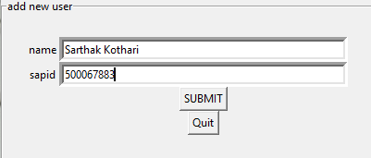

* Click on quit if no more data is to be added. You will be redirect to the Main Menu.



* Click on Train images.
* Enter the Unique identification number of person that you have enter in details of that person. **Make sure you enter correct the number.**

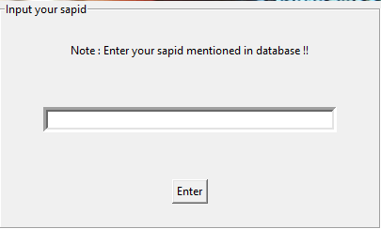

* Click on “open camera” to capture the images of person without mask. Click on “done” once images have been captured.

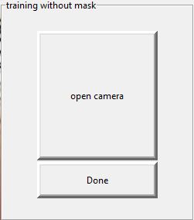



* Click on “open camera” to capture the images of person with mask. Click on done once images have been captured. **Make sure person is wearing a mask and there should be proper light in the room.**

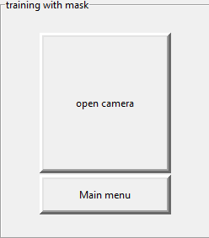

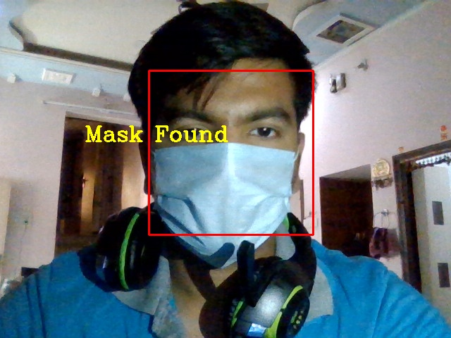

* Click on main menu once you are done.
* Click on recognizer to open camera to start recognizing persons.



Thank you for using the software.